ASSIGNMENT = JAVA PART
Task 1: Conditional Statements
In a BookingSystem, you have been given the task is to create a program to book tickets. if available tickets more than noOfTicket to book then display the remaining tickets or ticket unavailable
Tasks:
1. Write a program that takes the availableTicket and noOfBookingTicket as input.
2. Use conditional statements (if-else) to determine if the ticket is available or not.
3. Display an appropriate message based on ticket availability.
CODE :
package com.hexaware.ticketbookinginfo.entity;

import java.util.Scanner;

public class TicketBooking {
public static void main(String[] args) {
Scanner sc = new Scanner(System.in);

System.out.print("Enter available tickets: ");
int availableTicket = sc.nextInt();

System.out.print("Enter number of tickets to book: ");
int noOfBookingTicket = sc.nextInt();

if (availableTicket >= noOfBookingTicket) {
int remaining = availableTicket - noOfBookingTicket;
System.out.println("Tickets booked successfully!");
System.out.println("Remaining tickets: " + remaining);
} else {
System.out.println("Tickets unavailable!");
}

sc.close();
}
}
OUTPUT :
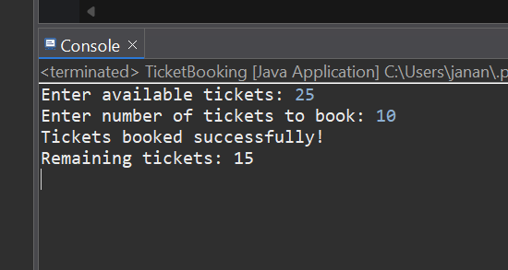
Task 2: Nested Conditional Statements
Create a program that simulates a Ticket booking and calculating cost of tickets. Display tickets options such as "Silver", "Gold", "Dimond". Based on ticket category fix the base ticket price and get the user input for ticket type and no of tickets need and calculate the total cost of tickets booked.
CODE :
package com.hexaware.ticketbookinginfo.entity;
import java.util.Scanner;

public class TicketBooking {
public static void main(String[] args) {
Scanner sc = new Scanner(System.in);

System.out.println("Available Ticket Types: Silver, Gold, Diamond");
System.out.print("Enter ticket type: ");
String ticketType = sc.nextLine();

System.out.print("Enter number of tickets: ");
int numberOfTickets = sc.nextInt();

int pricePerTicket = 0;

if (ticketType.equalsIgnoreCase("Silver")) {
pricePerTicket = 100;
} else if (ticketType.equalsIgnoreCase("Gold")) {
pricePerTicket = 200;
} else if (ticketType.equalsIgnoreCase("Diamond")) {
pricePerTicket = 300;
} else {
System.out.println("Invalid ticket type selected.");
sc.close();
return;
}

int totalCost = pricePerTicket * numberOfTickets;

System.out.println("Ticket Type: " + ticketType);
System.out.println("Number of Tickets: " + numberOfTickets);
System.out.println("Total Cost: Rs. " + totalCost);

sc.close();
}
}
OUTPUT:
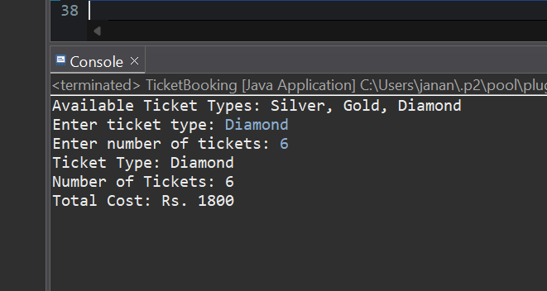
Task 3: Looping
From the above task book the tickets for repeatedly until user type "Exit"
CODE :
package com.hexaware.ticketbookinginfo.entity;
import java.util.Scanner;

public class TicketBooking{
public static void main(String[] args) {
Scanner sc = new Scanner(System.in);
int availableTickets = 50; // Initial ticket count

while (true) {
System.out.print("Enter ticket type (Silver/Gold/Diamond) or 'Exit' to quit: ");
String type = sc.next();

if (type.equalsIgnoreCase("Exit")) {
System.out.println("Booking stopped.");
break;
}

System.out.print("Enter number of tickets to book: ");
int count = sc.nextInt();

int price = 0;
if (type.equalsIgnoreCase("Silver")) {
price = 100;
} else if (type.equalsIgnoreCase("Gold")) {
price = 200;
} else if (type.equalsIgnoreCase("Diamond")) {
price = 300;
} else {
System.out.println("Invalid ticket type.");
continue;
}

if (availableTickets >= count) {
int total = count * price;
availableTickets -= count;
System.out.println("Booking successful! Total cost: ₹" + total);
System.out.println("Remaining tickets: " + availableTickets);
} else {
System.out.println("Not enough tickets available.");
}
}

sc.close();
}
}
OUTPUT:
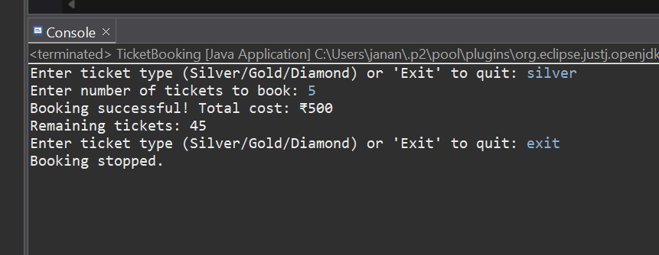
Task 4: Class & Object
Create a Following classes with the following attributes and methods:
    - 1. Event Class: •Attributes: o event_name,
    - o event_date DATE,
    - o event_time TIME,
    - o venue_name,
    - o total_seats,
    - o available_seats,
    - o ticket_price DECIMAL,
    - o event_type ENUM('Movie', 'Sports', 'Concert')

    - •Methods and Constuctors: o Implement default constructors and overload the constructor with Customer attributes, generate getter and setter, (print all information of attribute) methods for the attributes.
    - o calculate_total_revenue(): Calculate and return the total revenue based on the number of tickets sold.
    - o getBookedNoOfTickets(): return the total booked tickets
    - o book_tickets(num_tickets): Book a specified number of tickets for an event. Initially available seats are equal to the total seats when tickets are booked available seats number should be reduced.
    - o cancel_booking(num_tickets): Cancel the booking and update the available seats.
    - o display_event_details(): Display event details, including event name, date time seat availability.
CODE :

package com.hexaware.ticketbookinginfo.entity;

import java.time.LocalDate;
import java.time.LocalTime;

public class TicketBooking {

public static void main(String[] args) {
Event myEvent = new Event(
"Tech Fest",
LocalDate.of(2025, 5, 20),
LocalTime.of(10, 0),
"College Auditorium",
100,
250.0,
Event.EventType.Concert
);

myEvent.displayEventDetails();
myEvent.bookTickets(10);
myEvent.cancelBooking(2);
myEvent.displayEventDetails();
}
}

class Event {
private String eventName;
private LocalDate eventDate;
private LocalTime eventTime;
private String venueName;
private int totalSeats;
private int availableSeats;
private double ticketPrice;

public enum EventType {
Movie, Sports, Concert
}

private EventType eventType;

public Event() {
this.eventName = "";
this.eventDate = LocalDate.now();
this.eventTime = LocalTime.now();
this.venueName = "";
this.totalSeats = 0;
this.availableSeats = 0;
this.ticketPrice = 0.0;
this.eventType = EventType.Movie;
}

public Event(String eventName, LocalDate eventDate, LocalTime eventTime, String venueName,
int totalSeats, double ticketPrice, EventType eventType) {
this.eventName = eventName;
this.eventDate = eventDate;
this.eventTime = eventTime;
this.venueName = venueName;
this.totalSeats = totalSeats;
this.availableSeats = totalSeats;
this.ticketPrice = ticketPrice;
this.eventType = eventType;
}

public double calculateTotalRevenue() {
return (totalSeats - availableSeats) * ticketPrice;
}

public int getBookedNoOfTickets() {
return totalSeats - availableSeats;
}

public void bookTickets(int numTickets) {
if (numTickets <= availableSeats) {
availableSeats -= numTickets;
System.out.println(numTickets + " ticket(s) booked successfully!");
} else {
System.out.println("Not enough tickets available!");
}
}

public void cancelBooking(int numTickets) {
if (availableSeats + numTickets <= totalSeats) {
availableSeats += numTickets;
System.out.println(numTickets + " ticket(s) cancelled successfully!");
} else {
System.out.println("Invalid cancellation. Exceeds total seats.");
}
}

public void displayEventDetails() {
System.out.println("Event Name : " + eventName);
System.out.println("Event Date : " + eventDate);
System.out.println("Event Time : " + eventTime);
System.out.println("Venue : " + venueName);
System.out.println("Total Seats : " + totalSeats);
System.out.println("Available Seats: " + availableSeats);
System.out.println("Ticket Price : ₹" + ticketPrice);
System.out.println("Event Type : " + eventType);
System.out.println("Total Revenue : ₹" + calculateTotalRevenue());
System.out.println("-----------------------------");
}
}
OUTPUT :
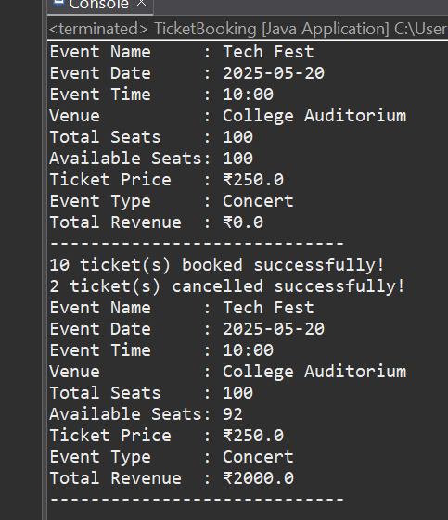
2.Venue Class •Attributes: o venue_name,
    - o address
    - •Methods and Constuctors: o display_venue_details(): Display venue details

    - o Implement default constructors and overload the constructor with Customer attributes, generate getter and setter methods.
CODE :
package com.hexaware.ticketbookinginfo.entity;

class Venue {
private String venue_name;
private String address;

public Venue() {
this.venue_name = "";
this.address = "";
}

public Venue(String venue_name, String address) {
this.venue_name = venue_name;
this.address = address;
}

public String getVenue_name() {
return venue_name;
}

public void setVenue_name(String venue_name) {
this.venue_name = venue_name;
}

public String getAddress() {
return address;
}

public void setAddress(String address) {
this.address = address;
}

public void display_venue_details() {
System.out.println("Venue Name: " + venue_name);
System.out.println("Address: " + address);
}
}

public class TicketBooking {
public static void main(String[] args) {
Venue defaultVenue = new Venue();
defaultVenue.setVenue_name("Default Auditorium");
defaultVenue.setAddress("Coimbatore, Tamil Nadu");
System.out.println("Default Venue Details:");
defaultVenue.display_venue_details();

System.out.println();
Venue customVenue = new Venue("Hexaware Event Hall", "Chennai, Tamil Nadu");
System.out.println("Custom Venue Details:");
customVenue.display_venue_details();
}
}
OUTPUT:
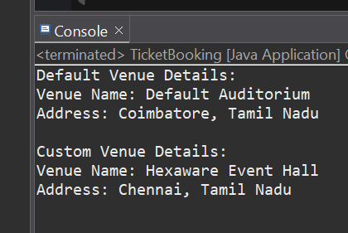
3. Customer Class
•Attributes: o customer_name,
    - o email,
    - o phone_number,
    - •Methods and Constuctors: o Implement default constructors and overload the constructor with Customer attributes, generate getter and setter methods.
    - o display_customer_details(): Display customer details.
CODE :
package com.hexaware.ticketbookinginfo.entity;

public class TicketBooking {

static class Customer {
private String customer_name;
private String email;
private String phone_number;

public Customer() {
this.customer_name = "";
this.email = "";
this.phone_number = "";
}

public Customer(String customer_name, String email, String phone_number) {
this.customer_name = customer_name;
this.email = email;
this.phone_number = phone_number;
}

public String getCustomer_name() {
return customer_name;
}

public void setCustomer_name(String customer_name) {
this.customer_name = customer_name;
}

public String getEmail() {
return email;
}

public void setEmail(String email) {
this.email = email;
}

public String getPhone_number() {
return phone_number;
}

public void setPhone_number(String phone_number) {
this.phone_number = phone_number;
}

public void display_customer_details() {
System.out.println("Customer Name: " + customer_name);
System.out.println("Email: " + email);
System.out.println("Phone Number: " + phone_number);
}
}

public static void main(String[] args) {
Customer customer1 = new Customer();
customer1.setCustomer_name("Jananii");
customer1.setEmail("jananii@example.com");
customer1.setPhone_number("9876543210");

Customer customer2 = new Customer("Arun", "arun@example.com", "9123456780");

System.out.println("Customer 1 Details:");
customer1.display_customer_details();

System.out.println("\nCustomer 2 Details:");
customer2.display_customer_details();
}
}
OUTPUT:
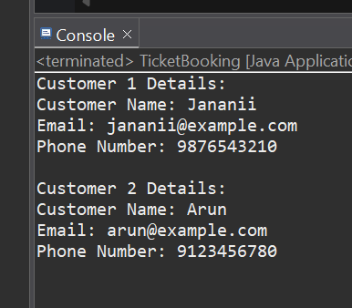
4. Booking Class to represent the Tiket booking system. Perform the following operation in main method. Note:- Use Event class object for the following operation.
•Methods and Constuctors: o calculate_booking_cost(num_tickets): Calculate and set the total cost of the booking.
    - o book_tickets(num_tickets): Book a specified number of tickets for an event.
    - o cancel_booking(num_tickets): Cancel the booking and update the available seats.
    - o getAvailableNoOfTickets(): return the total available tickets
    - o getEventDetails(): return event details from the event class
CODE :
package com.hexaware.ticketbookinginfo.entity;
import java.time.LocalDate;
import java.time.LocalTime;

public class TicketBooking {

enum EventType {
Movie, Sports, Concert
}

static class Event {
private String event_name;
private LocalDate event_date;
private LocalTime event_time;
private String venue_name;
private int total_seats;
private int available_seats;
private double ticket_price;
private EventType event_type;

public Event(String event_name, LocalDate event_date, LocalTime event_time,
String venue_name, int total_seats, double ticket_price, EventType event_type) {
this.event_name = event_name;
this.event_date = event_date;
this.event_time = event_time;
this.venue_name = venue_name;
this.total_seats = total_seats;
this.available_seats = total_seats;
this.ticket_price = ticket_price;
this.event_type = event_type;
}

public boolean book_tickets(int num_tickets) {
if (available_seats >= num_tickets) {
available_seats -= num_tickets;
return true;
} else {
System.out.println("Not enough seats available.");
return false;
}
}

public void cancel_booking(int num_tickets) {
available_seats += num_tickets;
if (available_seats > total_seats) {
available_seats = total_seats; // cap at max
}
System.out.println(num_tickets + " ticket(s) canceled.");
}

public double calculate_booking_cost(int num_tickets) {
return ticket_price * num_tickets;
}

public int getAvailableNoOfTickets() {
return available_seats;
}

public String getEventDetails() {
return "Event: " + event_name +
"\nDate: " + event_date +
"\nTime: " + event_time +
"\nVenue: " + venue_name +
"\nTotal Seats: " + total_seats +
"\nAvailable Seats: " + available_seats +
"\nTicket Price: ₹" + ticket_price +
"\nEvent Type: " + event_type;
}
}

public static void main(String[] args) {
Event event = new Event(
"IPL Final Match",
LocalDate.of(2025, 5, 25),
LocalTime.of(19, 30),
"Chennai Stadium",
5000,
1500.0,
EventType.Sports
);

System.out.println("=== Event Details ===");
System.out.println(event.getEventDetails());

int ticketsToBook = 3;
if (event.book_tickets(ticketsToBook)) {
double cost = event.calculate_booking_cost(ticketsToBook);
System.out.println("\nBooked " + ticketsToBook + " ticket(s). Total Cost: ₹" + cost);
}

System.out.println("\nAvailable Tickets After Booking: " + event.getAvailableNoOfTickets())
event.cancel_booking(1);
System.out.println("Available Tickets After Cancellation: " + event.getAvailableNoOfTickets());
}
}
OUTPUT:
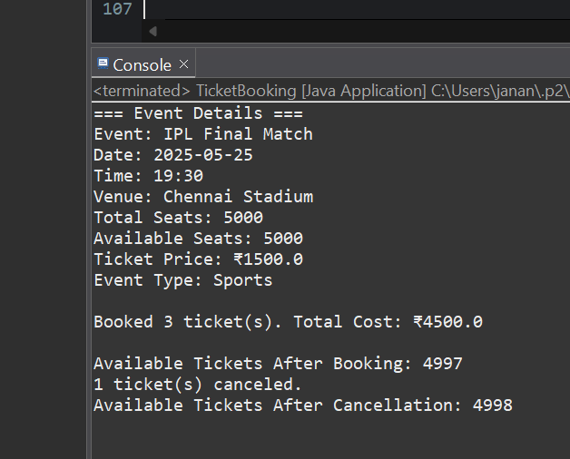
Task 5: Inheritance and polymorphism
    - 1. Inheritance •Create a subclass Movie that inherits from Event. Add the following attributes and methods: o Attributes: 1. genre: Genre of the movie (e.g., Action, Comedy, Horror).
    - 2. ActorName
    - 3. ActresName

    - o Methods: 1. Implement default constructors and overload the constructor with Customer attributes, generate getter and setter methods.
    - 2. display_event_details(): Display movie details, including genre.

    - •Create another subclass Concert that inherits from Event. Add the following attributes and methods: o Attributes: 1. artist: Name of the performing artist or band.
    - 2. type: (Theatrical, Classical, Rock, Recital)

    - o Methods: 1. Implement default constructors and overload the constructor with Customer attributes, generate getter and setter methods.
    - 2. display_concert_details(): Display concert details, including the artist.

    - •Create another subclass Sports that inherits from Event. Add the following attributes and methods: o Attributes: 1. sportName: Name of the game.
    - 2. teamsName: (India vs Pakistan)

    - o Methods: 1. Implement default constructors and overload the constructor with Customer attributes, generate getter and setter methods.
    - 2. display_sport_details(): Display concert details, including the artist.

    - •Create a class TicketBookingSystem with the following methods: o create_event(event_name: str, date:str, time:str, total_seats: int, ticket_price: float, event_type: str, venu_name:str): Create a new event with the specified details and event type (movie, sport or concert) and return event object.
    - o display_event_details(event: Event): Accepts an event object and calls its display_event_details() method to display event details.
    - o book_tickets(event: Event, num_tickets: int): 1. Accepts an event object and the number of tickets to be booked.
    - 2. Checks if there are enough available seats for the booking.
    - 3. If seats are available, updates the available seats and returns the total cost of the booking.
    - 4. If seats are not available, displays a message indicating that the event is sold out.

    - o cancel_tickets(event: Event, num_tickets): cancel a specified number of tickets for an event.
    - o main(): simulates the ticket booking system 1. User can book tickets and view the event details as per their choice in menu (movies, sports, concerts).
    - 2. Display event details using the display_event_details() method without knowing the specific event type (demonstrate polymorphism).
    - 3. Make bookings using the book_tickets() and cancel tickets cancel_tickets() method.

CODE : EVENT CLASS
public class Event {
protected String eventName, date, time, venueName;
protected int totalSeats, availableSeats;
protected double ticketPrice;

public Event() {}

public Event(String eventName, String date, String time, int totalSeats, double ticketPrice, String venueName) {
this.eventName = eventName;
this.date = date;
this.time = time;
this.totalSeats = totalSeats;
this.availableSeats = totalSeats;
this.ticketPrice = ticketPrice;
this.venueName = venueName;
}

public void displayEventDetails() {
System.out.println("Event Name: " + eventName);
System.out.println("Date: " + date);
System.out.println("Time: " + time);
System.out.println("Venue: " + venueName);
System.out.println("Ticket Price: " + ticketPrice);
System.out.println("Available Seats: " + availableSeats);
}
}

MOVIE CLASS :

public class Movie extends Event {
private String genre, actorName, actressName;

public Movie() {}

public Movie(String eventName, String date, String time, int totalSeats, double ticketPrice, String venueName,
String genre, String actorName, String actressName) {
super(eventName, date, time, totalSeats, ticketPrice, venueName);
this.genre = genre;
this.actorName = actorName;
this.actressName = actressName;
}

public void displayEventDetails() {
super.displayEventDetails();
System.out.println("Genre: " + genre);
System.out.println("Actor: " + actorName);
System.out.println("Actress: " + actressName);
}
}

CONCERT CLASS :
public class Concert extends Event {
private String artist, type;

public Concert() {}

public Concert(String eventName, String date, String time, int totalSeats, double ticketPrice, String venueName,
String artist, String type) {
super(eventName, date, time, totalSeats, ticketPrice, venueName);
this.artist = artist;
this.type = type;
}

public void displayEventDetails() {
super.displayEventDetails();
System.out.println("Artist: " + artist);
System.out.println("Type: " + type);
}
}

SPORTS CLASS :
public class Sports extends Event {
private String sportName, teamsName;

public Sports() {}

public Sports(String eventName, String date, String time, int totalSeats, double ticketPrice, String venueName,
String sportName, String teamsName) {
super(eventName, date, time, totalSeats, ticketPrice, venueName);
this.sportName = sportName;
this.teamsName = teamsName;
}

public void displayEventDetails() {
super.displayEventDetails();
System.out.println("Sport: " + sportName);
System.out.println("Teams: " + teamsName);
}
}

MAIN METHOD : TICKETBOOKING SYSTEM
import java.util.Scanner;

public class TicketBookingSystem {

public Event createEvent(String eventType, Scanner sc) {
System.out.print("Enter Event Name: ");
String name = sc.next();
System.out.print("Enter Date: ");
String date = sc.next();
System.out.print("Enter Time: ");
String time = sc.next();
System.out.print("Enter Total Seats: ");
int seats = sc.nextInt();
System.out.print("Enter Ticket Price: ");
double price = sc.nextDouble();
System.out.print("Enter Venue: ");
String venue = sc.next();

switch (eventType.toLowerCase()) {
case "movie":
System.out.print("Enter Genre: ");
String genre = sc.next();
System.out.print("Enter Actor Name: ");
String actor = sc.next();
System.out.print("Enter Actress Name: ");
String actress = sc.next();
return new Movie(name, date, time, seats, price, venue, genre, actor, actress);
case "concert":
System.out.print("Enter Artist: ");
String artist = sc.next();
System.out.print("Enter Type (Theatrical/Classical/Rock/Recital): ");
String type = sc.next();
return new Concert(name, date, time, seats, price, venue, artist, type);
case "sports":
System.out.print("Enter Sport Name: ");
String sport = sc.next();
System.out.print("Enter Teams (e.g., India vs Pakistan): ");
String teams = sc.next();
return new Sports(name, date, time, seats, price, venue, sport, teams);
default:
return null;
}
}

public void displayEventDetails(Event event) {
if (event != null) {
event.displayEventDetails(); // Polymorphism
}
}

public double bookTickets(Event event, int numTickets) {
if (event.availableSeats >= numTickets) {
event.availableSeats -= numTickets;
return numTickets * event.ticketPrice;
} else {
System.out.println("Not enough seats available.");
return 0.0;
}
}

public void cancelTickets(Event event, int numTickets) {
event.availableSeats += numTickets;
System.out.println(numTickets + " ticket(s) cancelled.");
}

public static void main(String[] args) {
Scanner sc = new Scanner(System.in);
TicketBookingSystem system = new TicketBookingSystem();
Event event = null;
while (true) {
System.out.println("\n--- Ticket Booking System ---");
System.out.println("1. Create Event");
System.out.println("2. Display Event Details");
System.out.println("3. Book Tickets");
System.out.println("4. Cancel Tickets");
System.out.println("5. Exit");
System.out.print("Enter your choice: ");
int ch = sc.nextInt();

switch (ch) {
case 1:
System.out.print("Enter Event Type (movie/sports/concert): ");
String type = sc.next();
event = system.createEvent(type, sc);
break;
case 2:
if (event != null) {
system.displayEventDetails(event);
} else {
System.out.println("No event created yet.");
}
break;
case 3:
if (event != null) {
System.out.print("Enter number of tickets to book: ");
int bookCount = sc.nextInt();
double cost = system.bookTickets(event, bookCount);
if (cost > 0)
System.out.println("Total Cost: " + cost);
} else {
System.out.println("No event created yet.");
}
break;
case 4:
if (event != null) {
System.out.print("Enter number of tickets to cancel: ");
int cancelCount = sc.nextInt();
system.cancelTickets(event, cancelCount);
} else {
System.out.println("No event created yet.");
}
break;
case 5:
System.out.println("Thank you for using the system!");
return;
default:
System.out.println("Invalid choice.");
}
}
}
}

OUTPUT:
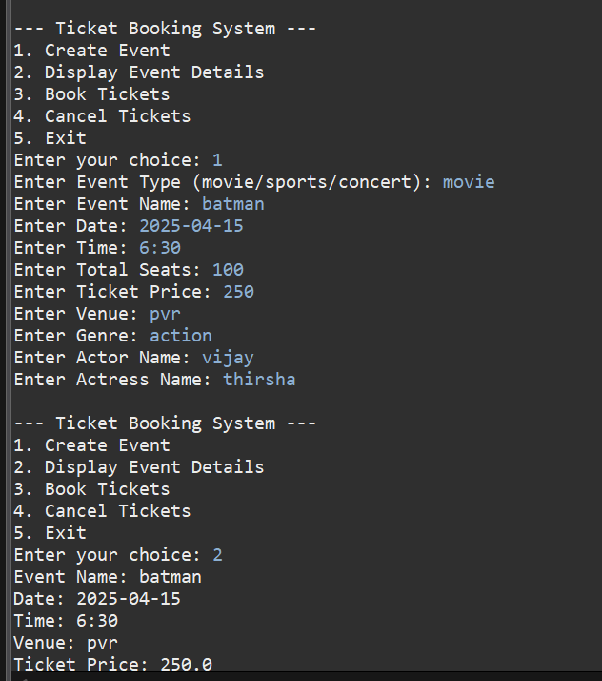

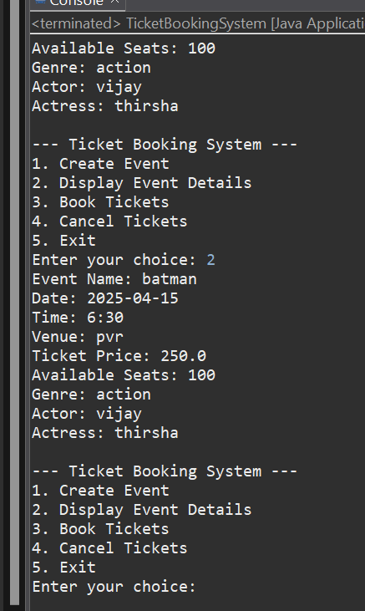
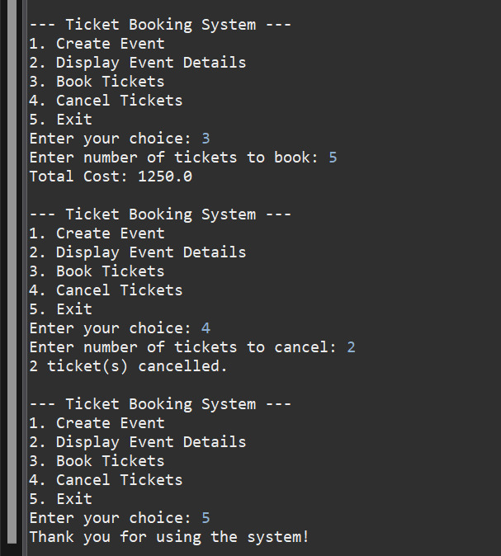

Task 6: Abstraction
Requirements:
  - 1. Event Abstraction: •Create an abstract class Event that represents a generic event. It should include the following attributes and methods as mentioned in TASK 1:

  - 2. Concrete Event Classes: •Create three concrete classes that inherit from Event abstract class and override abstract methods in concrete class should declare the variables as mentioned in above Task 2: •Movie.
  - •Concert.
  - •Sport.

  - 3. BookingSystem Abstraction: •Create an abstract class BookingSystem that represents the ticket booking system. It should include the methods of TASK 2 TicketBookingSystem:

  - 4. Concrete TicketBookingSystem Class:

  - •Create a concrete class TicketBookingSystem that inherits from BookingSystem: •TicketBookingSystem: Implement the abstract methods to create events, book tickets, and retrieve available seats. Maintain an array of events in this class.

  - •Create a simple user interface in a main method that allows users to interact with the ticket booking system by entering commands such as "create_event", "book_tickets", "cancel_tickets", "get_available_seats," and "exit."

CODE :
EVENT CLASS :
public abstract class Event {
protected String eventName, date, time, venue;
protected int totalSeats, availableSeats;
protected double ticketPrice;

public Event(String eventName, String date, String time, int totalSeats, double ticketPrice, String venue) {
this.eventName = eventName;
this.date = date;
this.time = time;
this.totalSeats = totalSeats;
this.availableSeats = totalSeats;
this.ticketPrice = ticketPrice;
this.venue = venue;
}

public abstract void displayEventDetails();

public int getAvailableSeats() {
return availableSeats;
}

public double bookTickets(int numTickets) {
if (numTickets <= availableSeats) {
availableSeats -= numTickets;
return ticketPrice * numTickets;
} else {
return -1;
}
}

public void cancelTickets(int numTickets) {
availableSeats += numTickets;
if (availableSeats > totalSeats)
availableSeats = totalSeats;
}
}

MOVIE CLASS:

public class Movie extends Event {
private String genre, actorName, actressName;

public Movie(String eventName, String date, String time, int totalSeats, double ticketPrice, String venue,
String genre, String actorName, String actressName) {
super(eventName, date, time, totalSeats, ticketPrice, venue);
this.genre = genre;
this.actorName = actorName;
this.actressName = actressName;
}

@Override
public void displayEventDetails() {
System.out.println("Movie Event");
System.out.println("Name: " + eventName + ", Genre: " + genre + ", Actor: " + actorName + ", Actress: " + actressName);
System.out.println("Date: " + date + ", Time: " + time + ", Venue: " + venue);
System.out.println("Price: " + ticketPrice + ", Available Seats: " + availableSeats);
}
}

CONCERT CLASS :
public class Concert extends Event {
private String artist, type;

public Concert(String eventName, String date, String time, int totalSeats, double ticketPrice, String venue,
String artist, String type) {
super(eventName, date, time, totalSeats, ticketPrice, venue);
this.artist = artist;
this.type = type;
}

@Override
public void displayEventDetails() {
System.out.println("Concert Event");
System.out.println("Name: " + eventName + ", Artist: " + artist + ", Type: " + type);
System.out.println("Date: " + date + ", Time: " + time + ", Venue: " + venue);
System.out.println("Price: " + ticketPrice + ", Available Seats: " + availableSeats);
}
}

SPORTS CLASS :
public class Sports extends Event {
private String sportName, teams;

public Sports(String eventName, String date, String time, int totalSeats, double ticketPrice, String venue,
String sportName, String teams) {
super(eventName, date, time, totalSeats, ticketPrice, venue);
this.sportName = sportName;
this.teams = teams;
}

@Override
public void displayEventDetails() {
System.out.println("Sports Event");
System.out.println("Name: " + eventName + ", Sport: " + sportName + ", Teams: " + teams);
System.out.println("Date: " + date + ", Time: " + time + ", Venue: " + venue);
System.out.println("Price: " + ticketPrice + ", Available Seats: " + availableSeats);
}
}
BOOKINGSYSTEM CLASS :
public abstract class BookingSystem {
public abstract void createEvent();
public abstract void bookTickets();
public abstract void cancelTickets();
public abstract void getAvailableSeats();
}

TICKETBOOKING SYSTEM:

import java.util.*;

public class TicketBookingSystem extends BookingSystem {
private List<Event> events = new ArrayList<>();
private Scanner sc = new Scanner(System.in);

@Override
public void createEvent() {
System.out.print("Enter Event Type (movie/concert/sports): ");
String type = sc.next().toLowerCase();
System.out.print("Event Name: ");
String name = sc.next();
System.out.print("Date: ");
String date = sc.next();
System.out.print("Time: ");
String time = sc.next();
System.out.print("Total Seats: ");
int seats = sc.nextInt();
System.out.print("Ticket Price: ");
double price = sc.nextDouble();
System.out.print("Venue: ");
String venue = sc.next();

Event event = null;
switch (type) {
case "movie":
System.out.print("Genre: ");
String genre = sc.next();
System.out.print("Actor Name: ");
String actor = sc.next();
System.out.print("Actress Name: ");
String actress = sc.next();
event = new Movie(name, date, time, seats, price, venue, genre, actor, actress);
break;
case "concert":
System.out.print("Artist: ");
String artist = sc.next();
System.out.print("Type: ");
String concertType = sc.next();
event = new Concert(name, date, time, seats, price, venue, artist, concertType);
break;
case "sports":
System.out.print("Sport Name: ");
String sport = sc.next();
System.out.print("Teams: ");
String teams = sc.next();
event = new Sports(name, date, time, seats, price, venue, sport, teams);
break;
default:
System.out.println("Invalid event type.");
return;
}
events.add(event);
System.out.println("Event created successfully!");
}

@Override
public void bookTickets() {
if (events.isEmpty()) {
System.out.println("No events available.");
return;
}
displayEvents();
System.out.print("Enter event number to book: ");
int index = sc.nextInt();
if (index < 1 || index > events.size()) {
System.out.println("Invalid selection.");
return;
}
Event e = events.get(index - 1);
System.out.print("Number of tickets: ");
int tickets = sc.nextInt();
double cost = e.bookTickets(tickets);
if (cost == -1) {
System.out.println("Not enough seats.");
} else {
System.out.println("Booking successful! Total cost: " + cost);
}
}

@Override
public void cancelTickets() {
if (events.isEmpty()) {
System.out.println("No events available.");
return;
}
displayEvents();
System.out.print("Enter event number to cancel tickets: ");
int index = sc.nextInt();
if (index < 1 || index > events.size()) {
System.out.println("Invalid selection.");
return;
}
Event e = events.get(index - 1);
System.out.print("Number of tickets to cancel: ");
int tickets = sc.nextInt();
e.cancelTickets(tickets);
System.out.println("Tickets cancelled.");
}

@Override
public void getAvailableSeats() {
if (events.isEmpty()) {
System.out.println("No events available.");
return;
}
displayEvents();
System.out.print("Enter event number to check available seats: ");
int index = sc.nextInt();
if (index < 1 || index > events.size()) {
System.out.println("Invalid selection.");
return;
}
Event e = events.get(index - 1);
System.out.println("Available Seats: " + e.getAvailableSeats());
}

private void displayEvents() {
System.out.println("\n--- Events ---");
for (int i = 0; i < events.size(); i++) {
System.out.print((i + 1) + ". ");
events.get(i).displayEventDetails();
}
}

public static void main(String[] args) {
TicketBookingSystem system = new TicketBookingSystem();
Scanner sc = new Scanner(System.in);
while (true) {
System.out.println("\n--- Ticket Booking System ---");
System.out.println("Commands: create_event | book_tickets | cancel_tickets | get_available_seats | exit");
System.out.print("Enter command: ");
String command = sc.next().toLowerCase();
switch (command) {
case "create_event":
system.createEvent();
break;
case "book_tickets":
system.bookTickets();
break;
case "cancel_tickets":
system.cancelTickets();
break;
case "get_available_seats":
system.getAvailableSeats();
break;
case "exit":
System.out.println("Exiting system. Thank you!");
return;
default:
System.out.println("Invalid command.");
}
}
}

OUTPUT:
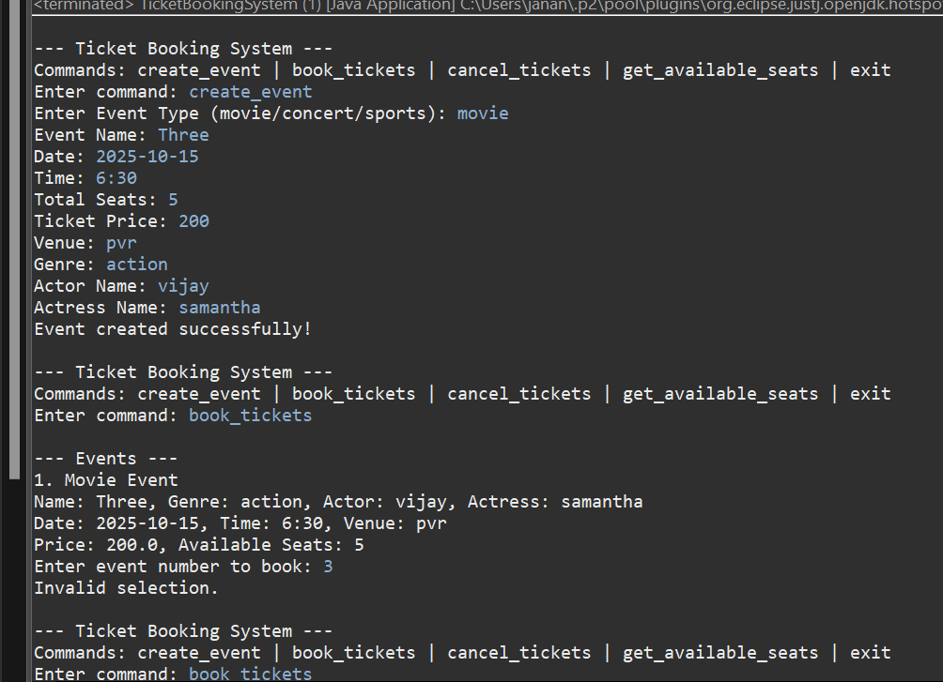

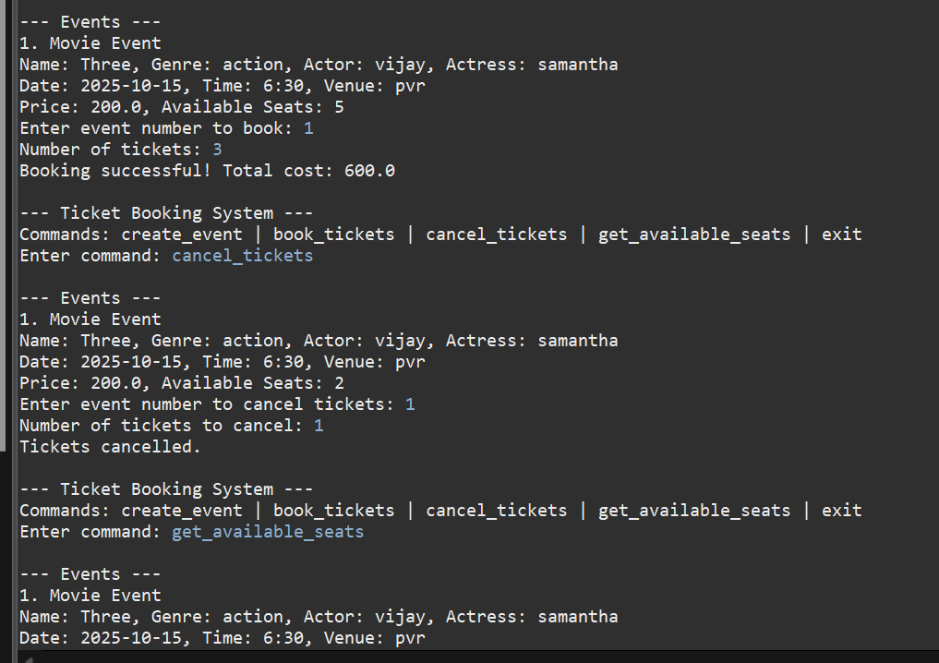

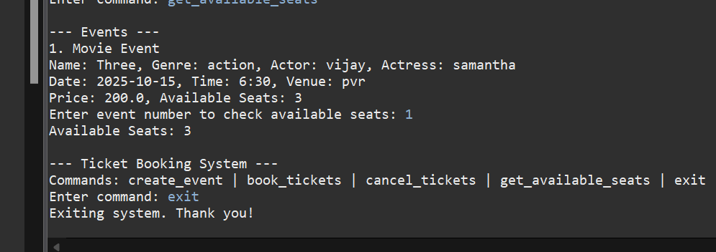

Task 7: Has A Relation / Association
Create a Following classes with the following attributes and methods:
    - 1. Venue Class •Attributes: o venue_name,
    - o address

    - •Methods and Constuctors: o display_venue_details(): Display venue details.
    - o Implement default constructors and overload the constructor with Customer attributes, generate getter and setter methods.

    - 2. Event Class: •Attributes: o event_name,
    - o event_date DATE,
    - o event_time TIME,
    - o venue (reference of class Venu),
    - o total_seats,
    - o available_seats,
    - o ticket_price DECIMAL,
    - o event_type ENUM('Movie', 'Sports', 'Concert')

    - •Methods and Constuctors: o Implement default constructors and overload the constructor with Customer attributes, generate getter and setter, (print all information of attribute) methods for the attributes.
    - o calculate_total_revenue(): Calculate and return the total revenue based on the number of tickets sold.
    - o getBookedNoOfTickets(): return the total booked tickets
    - o book_tickets(num_tickets): Book a specified number of tickets for an event. Initially available seats are equal to total seats when tickets are booked available seats number should be reduced.
    - o cancel_booking(num_tickets): Cancel the booking and update the available seats.
    - o display_event_details(): Display event details, including event name, date time seat availability.

    - 3. Event sub classes: •Create three sub classes that inherit from Event abstract class and override abstract methods in concrete class should declare the variables as mentioned in above Task 2: o Movie.

    - Concert.
    - o Sport.

    - •Attributes: o customer_name,
    - o email,
    - o phone_number,

    - •Methods and Constuctors: o Implement default constructors and overload the constructor with Customer attributes, generate getter and setter methods.
    - o display_customer_details(): Display customer details.

    - •bookingId (should be incremented for each booking)
    - •array of customer (reference to the customer who made the booking)
    - •event (reference to the event booked)
    - •num_tickets(no of tickets and array of customer must equal)
    - •total_cost
    - •booking_date (timestamp of when the booking was made)
    - •Methods and Constuctors: o Implement default constructors and overload the constructor with Customer attributes, generate getter and setter methods.
    - o display_booking_details(): Display customer details.

    - •Attributes o array of events

    - •Methods and Constuctors: o create_event(event_name: str, date:str, time:str, total_seats: int, ticket_price: float, event_type: str, venu:Venu): Create a new event with the specified details and event type (movie, sport or concert) and return event object.
    - o calculate_booking_cost(num_tickets): Calculate and set the total cost of the booking.
    - o book_tickets(eventname:str, num_tickets, arrayOfCustomer): Book a specified number of tickets for an event. for each tickets customer object should be created and stored in array also should update the attributes of Booking class.
    - o cancel_booking(booking_id): Cancel the booking and update the available seats.
    - o getAvailableNoOfTickets(): return the total available tickets
    - o getEventDetails(): return event details from the event class
    - o Create a simple user interface in a main method that allows users to interact with the ticket booking system by entering commands such as "create_event", "book_tickets", "cancel_tickets", "get_available_seats,", "get_event_details," and "exit."

4. Customer Class
5. Create a class Booking with the following attributes:
6. BookingSystem Class to represent the Ticket booking system. Perform the following operation in main method. Note: - Use Event class object for the following operation.

CODE :

VENUE CLASS : public class Venue {
private String venueName;
private String address;

public Venue() {}

public Venue(String venueName, String address) {
this.venueName = venueName;
this.address = address;
}

public String getVenueName() {
return venueName;
}

public void setVenueName(String venueName) {
this.venueName = venueName;
}

public String getAddress() {
return address;
}

public void setAddress(String address) {
this.address = address;
}

public void displayVenueDetails() {
System.out.println("Venue: " + venueName + ", Address: " + address);
}
}
EVENT CLASS :

import java.time.LocalDate;
import java.time.LocalTime;

public abstract class Event {
protected String eventName;
protected LocalDate eventDate;
protected LocalTime eventTime;
protected Venue venue;
protected int totalSeats;
protected int availableSeats;
protected double ticketPrice;
protected String eventType;

public Event() {}

public Event(String eventName, LocalDate eventDate, LocalTime eventTime, Venue venue,
int totalSeats, double ticketPrice, String eventType) {
this.eventName = eventName;
this.eventDate = eventDate;
this.eventTime = eventTime;
this.venue = venue;
this.totalSeats = totalSeats;
this.availableSeats = totalSeats;
this.ticketPrice = ticketPrice;
this.eventType = eventType;
}
public double calculateTotalRevenue() {
return (totalSeats - availableSeats) * ticketPrice;
}

public int getBookedNoOfTickets() {
return totalSeats - availableSeats;
}

public void bookTickets(int numTickets) {
if (availableSeats >= numTickets) {
availableSeats -= numTickets;
} else {
System.out.println("Not enough seats available!");
}
}

public void cancelBooking(int numTickets) {
availableSeats += numTickets;
}

public void displayEventDetails() {
System.out.println("Event: " + eventName + " | Type: " + eventType + " | Date: " + eventDate + " | Time: " + eventTime);
System.out.println("Seats: " + availableSeats + "/" + totalSeats + " | Ticket Price: " + ticketPrice);
venue.displayVenueDetails();
}

public String getEventName() {
return eventName;
}

public int getAvailableSeats() {
return availableSeats;
}

public String getEventType() {
return eventType;
}
}
MOVIE CLASS :
import java.time.LocalDate;
import java.time.LocalTime;

public class Movie extends Event {
private String genre;
private String actorName;
private String actressName;

public Movie(String eventName, LocalDate eventDate, LocalTime eventTime, Venue venue,
int totalSeats, double ticketPrice, String genre, String actorName, String actressName) {
super(eventName, eventDate, eventTime, venue, totalSeats, ticketPrice, "Movie");
this.genre = genre;
this.actorName = actorName;
this.actressName = actressName;
}

@Override
public void displayEventDetails() {
super.displayEventDetails();
System.out.println("Genre: " + genre + ", Actor: " + actorName + ", Actress: " + actressName);
}
}
CONCERT CLASS:
import java.time.LocalDate;
import java.time.LocalTime;

public class Concert extends Event {
private String artist;
private String type;

public Concert(String eventName, LocalDate eventDate, LocalTime eventTime, Venue venue,
int totalSeats, double ticketPrice, String artist, String type) {
super(eventName, eventDate, eventTime, venue, totalSeats, ticketPrice, "Concert");
this.artist = artist;
this.type = type;
}

@Override
public void displayEventDetails() {
super.displayEventDetails();
System.out.println("Artist: " + artist + ", Type: " + type);
}
}
SPORT CLASS :
import java.time.LocalDate;
import java.time.LocalTime;

public class Sport extends Event {
private String sportName;
private String teamsName;

public Sport(String eventName, LocalDate eventDate, LocalTime eventTime, Venue venue,
int totalSeats, double ticketPrice, String sportName, String teamsName) {
super(eventName, eventDate, eventTime, venue, totalSeats, ticketPrice, "Sports");
this.sportName = sportName;
this.teamsName = teamsName;
}

@Override
public void displayEventDetails() {
super.displayEventDetails();
System.out.println("Sport: " + sportName + ", Teams: " + teamsName);
}
}

CUSTOMER CLASS :
public class Customer {
private String name;
private String email;
private String phoneNumber;

public Customer() {}

public Customer(String name, String email, String phoneNumber) {
this.name = name;
this.email = email;
this.phoneNumber = phoneNumber;
}

public void displayCustomerDetails() {
System.out.println("Customer: " + name + ", Email: " + email + ", Phone: " + phoneNumber);
}
}
BOOKING CLASS:
import java.time.LocalDateTime;

public class Booking {
private static int bookingCounter = 1000;
private int bookingId;
private Customer[] customers;
private Event event;
private int numTickets;
private double totalCost;
private LocalDateTime bookingDate;

public Booking(Customer[] customers, Event event, int numTickets) {
this.bookingId = bookingCounter++;
this.customers = customers;
this.event = event;
this.numTickets = numTickets;
this.totalCost = event.ticketPrice * numTickets;
this.bookingDate = LocalDateTime.now();
}

public int getBookingId() {
return bookingId;
}

public int getNumTickets() {
return numTickets;
}
public Event getEvent() {
return event;
}

public void displayBookingDetails() {
System.out.println("Booking ID: " + bookingId + " | Event: " + event.getEventName());
System.out.println("Tickets: " + numTickets + " | Total Cost: " + totalCost + " | Date: " + bookingDate);
for (Customer customer : customers) {
customer.displayCustomerDetails();
}
}
}

BOOKINGSYSTEM MAIN METHOD:
CODE :
import java.util.*;
import java.time.LocalDate;
import java.time.LocalTime;
import java.time.LocalDateTime;

public class BookingSystem {
public static void main(String[] args) {
Scanner sc = new Scanner(System.in);
ArrayList<Event> events = new ArrayList<>();
ArrayList<Booking> bookings = new ArrayList<>();

while (true) {
System.out.println("\n1. Create Event\n2. Book Tickets\n3. Cancel Booking\n4. Get Available Tickets\n5. Get Event Details\n6. Exit");
int choice = sc.nextInt();
sc.nextLine();

switch (choice) {
case 1:
System.out.print("Event Type (movie/sports/concert): ");
String type = sc.nextLine();
System.out.print("Event Name: ");
String name = sc.nextLine();
System.out.print("Event Date (yyyy-mm-dd): ");
LocalDate date = LocalDate.parse(sc.nextLine());
System.out.print("Event Time (HH:mm): ");
LocalTime time = LocalTime.parse(sc.nextLine());
System.out.print("Total Seats: ");
int seats = sc.nextInt();
System.out.print("Ticket Price: ");
double price = sc.nextDouble(); sc.nextLine();
System.out.print("Venue Name: ");
String venueName = sc.nextLine();
System.out.print("Venue Address: ");
String address = sc.nextLine();
System.out.print("Parameter 1 (Genre/Artist/Sport Name): ");
String param1 = sc.nextLine();
System.out.print("Parameter 2 (Actor/Concert Type/Team Names): ");
String param2 = sc.nextLine();

Venue venue = new Venue(venueName, address);
Event newEvent = null;

if (type.equalsIgnoreCase("movie")) {
newEvent = new Movie(name, date, time, venue, seats, price, type, param1, param2, "ActressName");
} else if (type.equalsIgnoreCase("sports")) {
newEvent = new Sport(name, date, time, venue, seats, price, type, param1, param2);
} else if (type.equalsIgnoreCase("concert")) {
newEvent = new Concert(name, date, time, venue, seats, price, type, param1, param2);
}

if (newEvent != null) {
events.add(newEvent);
System.out.println("Event created successfully.");
} else {
System.out.println("Invalid event type.");
}
break;

case 2:
System.out.print("Enter Event Name to Book Tickets: ");
String bookEventName = sc.nextLine();
Event selectedEvent = null;
for (Event ev : events) {
if (ev.getEventName().equalsIgnoreCase(bookEventName)) {
selectedEvent = ev;
break;
}
}

if (selectedEvent == null) {
System.out.println("Event not found.");
break;
}

System.out.print("Enter Number of Tickets: ");
int ticketCount = sc.nextInt(); sc.nextLine();
if (ticketCount > selectedEvent.getAvailableSeats()) {
System.out.println("Not enough available seats.");
break;
}

Customer[] customers = new Customer[ticketCount];
for (int i = 0; i < ticketCount; i++) {
System.out.println("Enter details for Customer " + (i + 1));
System.out.print("Name: ");
String cname = sc.nextLine();
System.out.print("Email: ");
String email = sc.nextLine();
System.out.print("Phone: ");
String phone = sc.nextLine();
customers[i] = new Customer(cname, email, phone);
}

Booking newBooking = new Booking(customers, selectedEvent, ticketCount);
bookings.add(newBooking);
System.out.println("Booking successful. Booking ID: " + newBooking.getBookingId());
break;

case 3:
System.out.print("Enter Booking ID to Cancel: ");
int cancelId = sc.nextInt(); sc.nextLine();
Booking foundBooking = null;
for (Booking b : bookings) {
if (b.getBookingId() == cancelId) {
foundBooking = b;
break;
}
}

if (foundBooking != null) {
foundBooking.getEvent().cancelBooking(foundBooking.getNumTickets());
bookings.remove(foundBooking);
System.out.println("Booking cancelled.");
} else {
System.out.println("Booking ID not found.");
}
break;

case 4:
for (Event ev : events) {
System.out.println(ev.getEventName() + ": " + ev.getAvailableSeats() + " seats available.");
}
break;

case 5:
for (Event ev : events) {
ev.displayEventDetails();
}
break;

case 6:
System.out.println("Exiting...");
sc.close();
return;

default:
System.out.println("Invalid choice. Try again.");
}
}
}
OUTPUT:
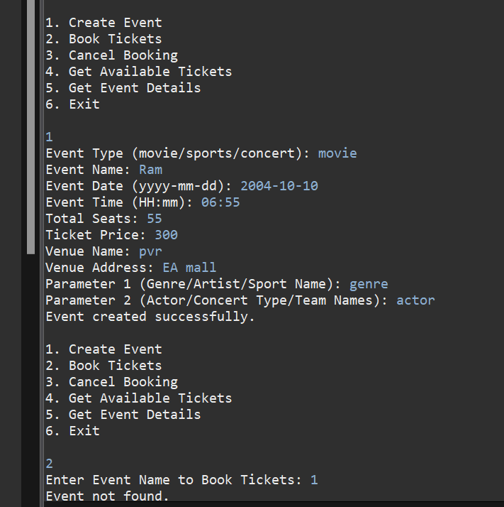

TASK = 8
